**Name: VYSHNAVI BABU S**

**Roll No:55**

**Batch:B**

**Date:24-03-22**

**NETWORKING & SYSTEM ADMINISTRATION LAB**

**Experiment No. 1**

**Aim**

Install the latest version of Ubuntu on an Oracle VM VirtualBox.

**Procedure**

**STEP 1**: Click ‘New’ button to open a dialog.

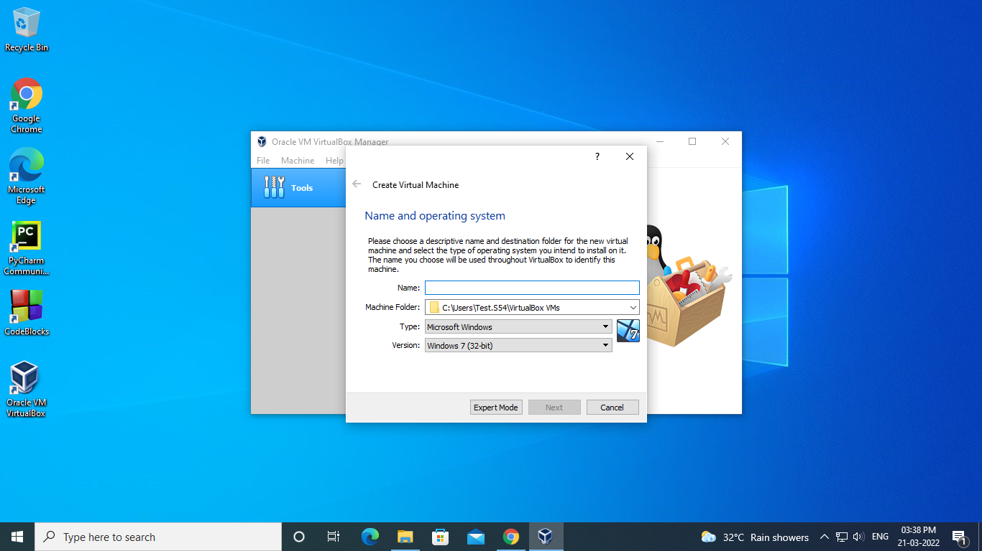

**STEP 2**: Type a name for the virtual machine.Let it be ubuntu102.Virtual box automatically get updated to type Linux and version to ‘Ubuntu(64 bit)’.

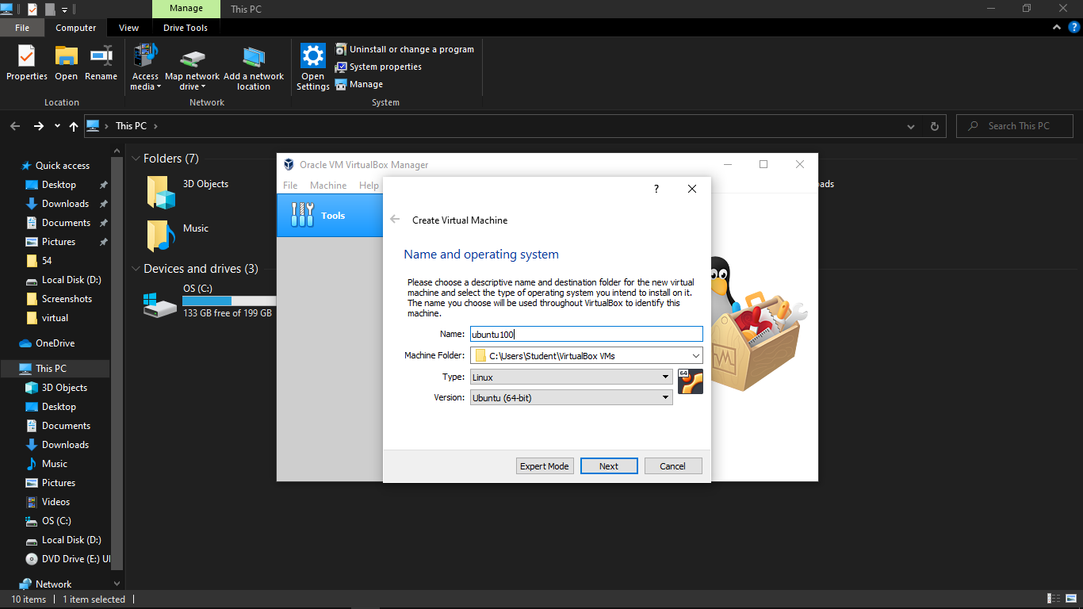

**STEP 3:** Allocating memory size say, 1024 MB.

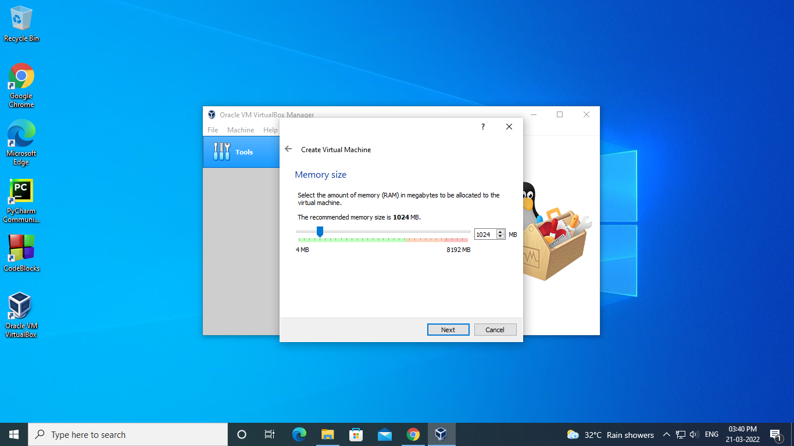

**STEP 4:** Accept the default 'Create a virtual hard drive now' and click 'Create' button.

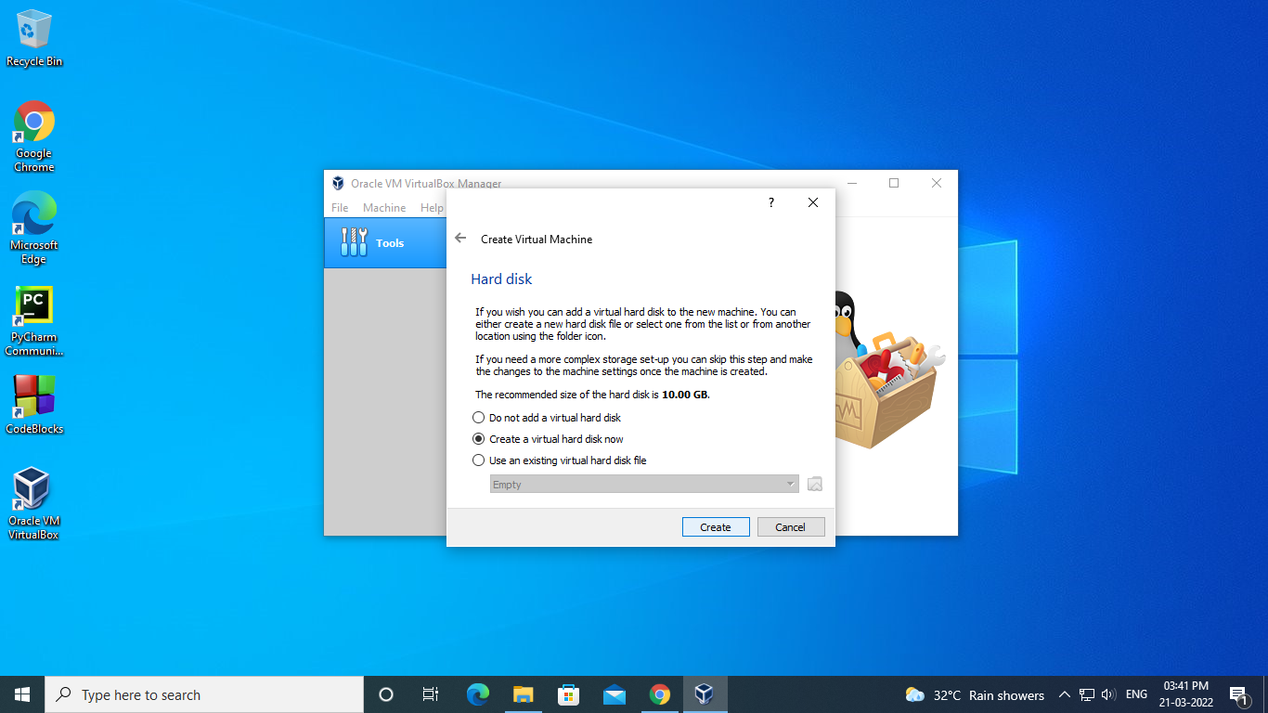

**STEP 5:** Click the default 'VDI' drive file type and click 'Next' button.

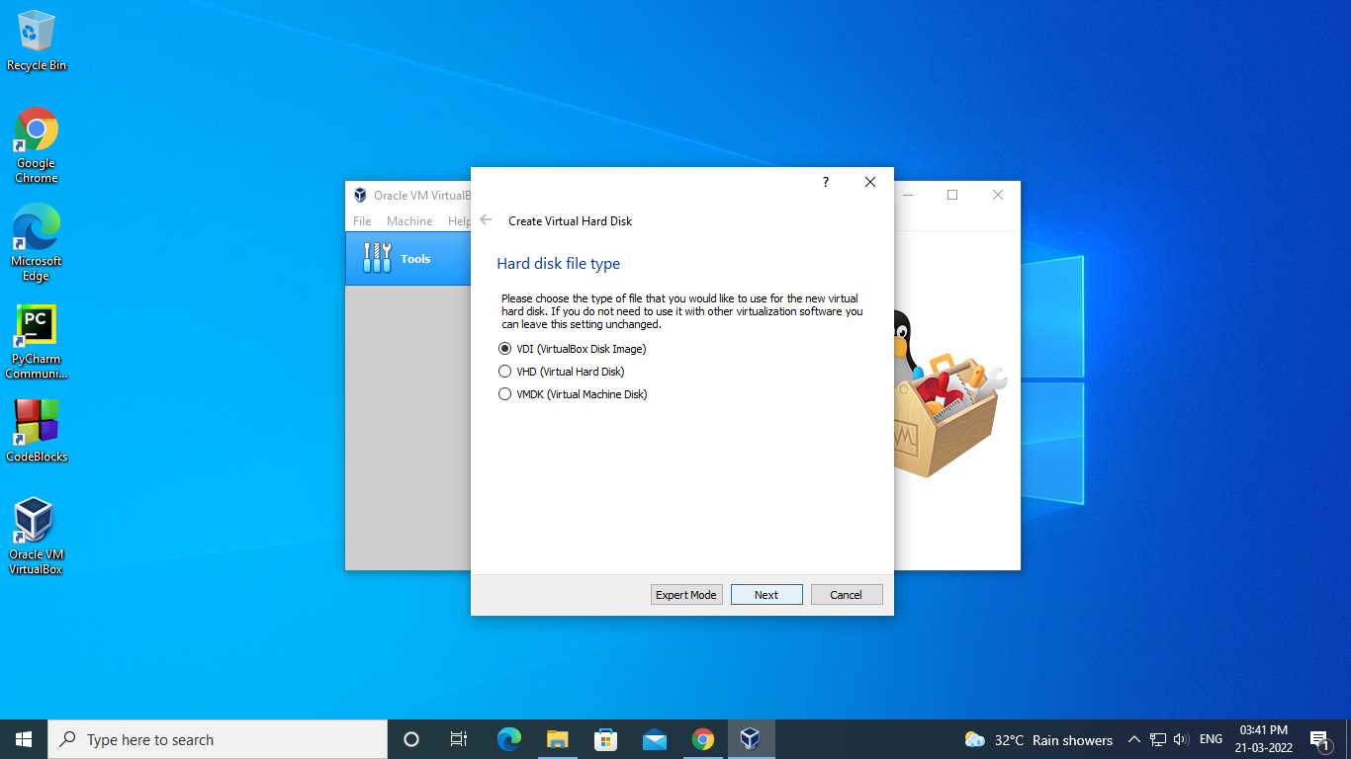

**STEP 6:** Change the storage type from the default 'Fixed size' to 'Dynamically allocated.

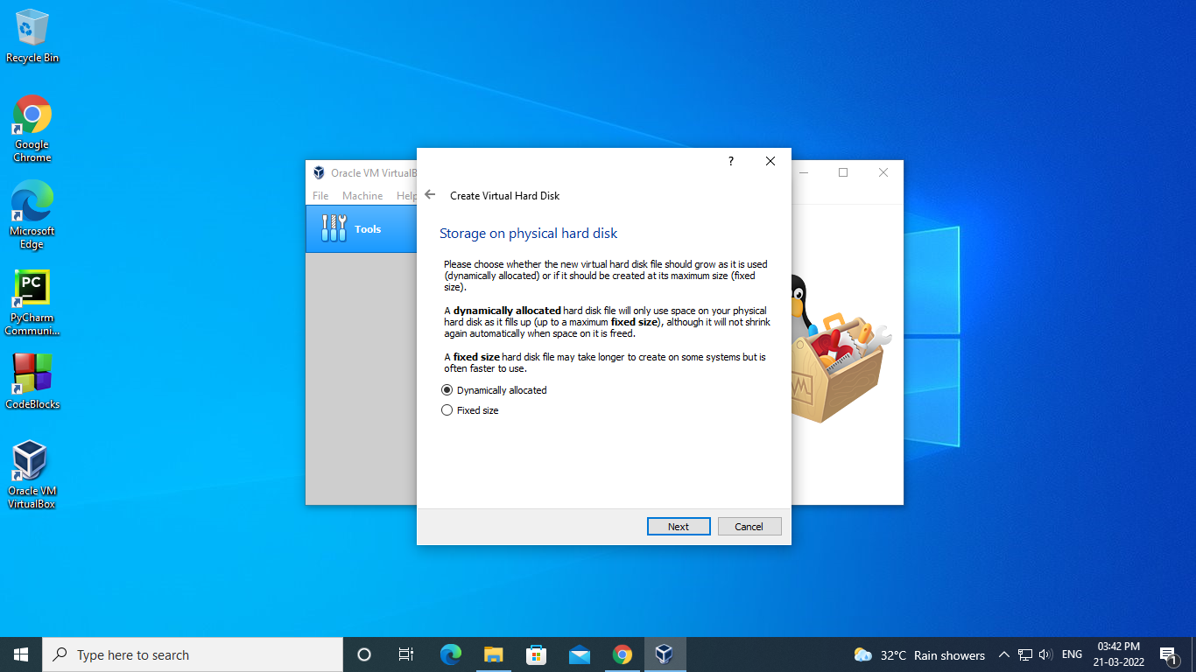

**STEP 7:** For the virtual hard drive space, the default value is 8GB .

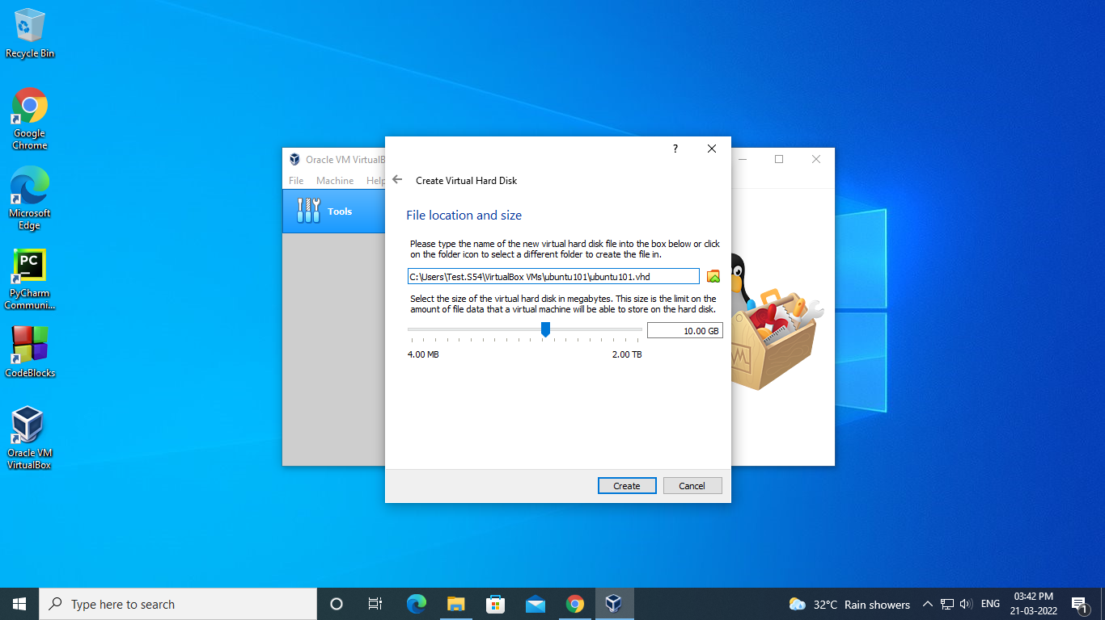

Click 'Create' button and VirtualBox will generate Ubuntu virtual machine.

**STEP 8:** The virtual machine is created. Now it is ready to install Ubuntu in this virtual machine. Select your new virtual machine and click 'Settings' button. Click on 'Storage' category and then 'Empty' under Controller:IDE. Click "CD/DVD" icon on right hand side and select the ubuntu ISO file to mount.

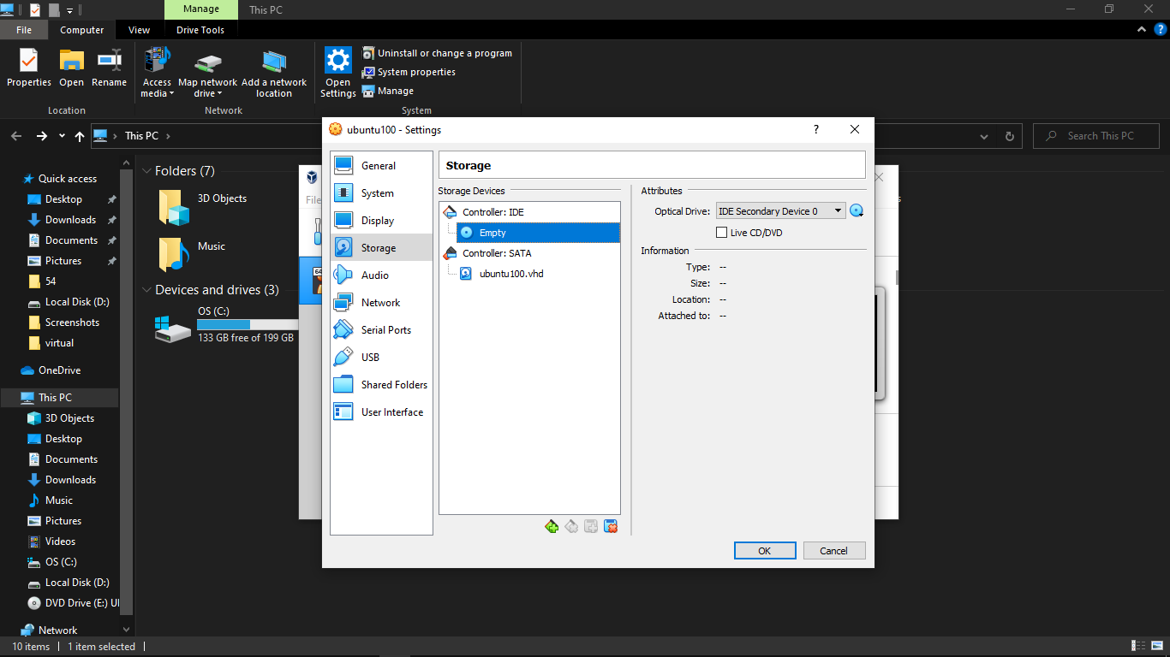

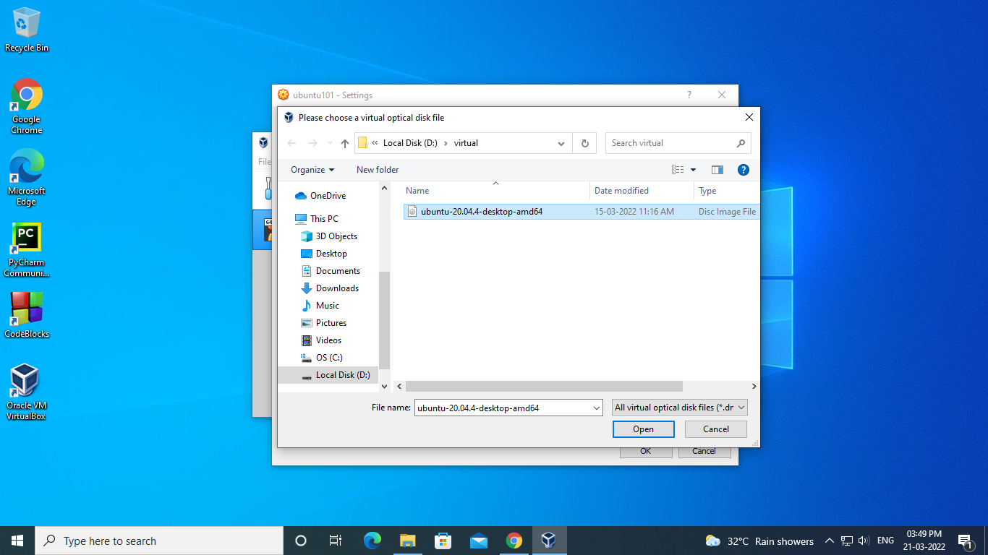

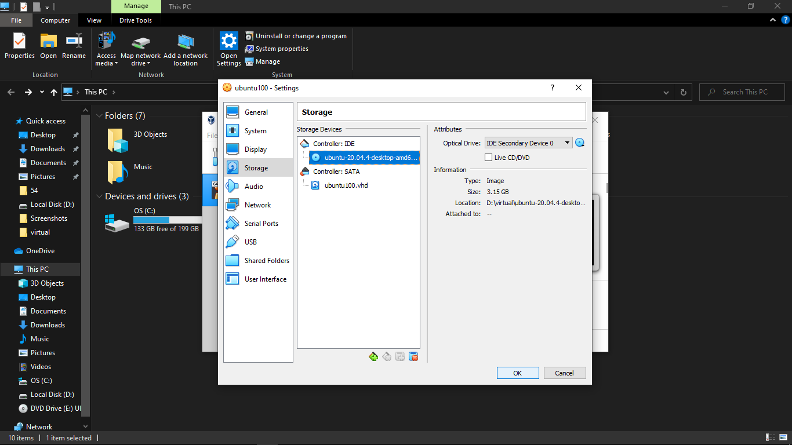

Now you can click 'OK' button to continue.

**STEP 9:** VirtualBox may pop up a message . Read the message and select 'Do not show this message again' option before clicking OK.

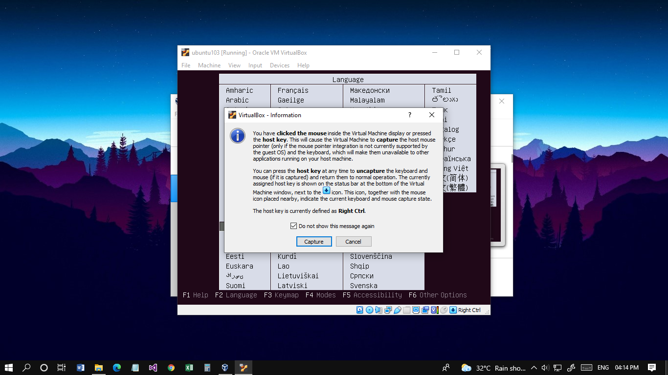

**INSTALL UBUNTU**

**STEP 10:** Back to Oracle VM VirtualBox Manager, click on the new Ubuntu virtual machine and hit 'Start' button. Now you shall see a 'Welcome' screen. Click 'Install Ubuntu' button.

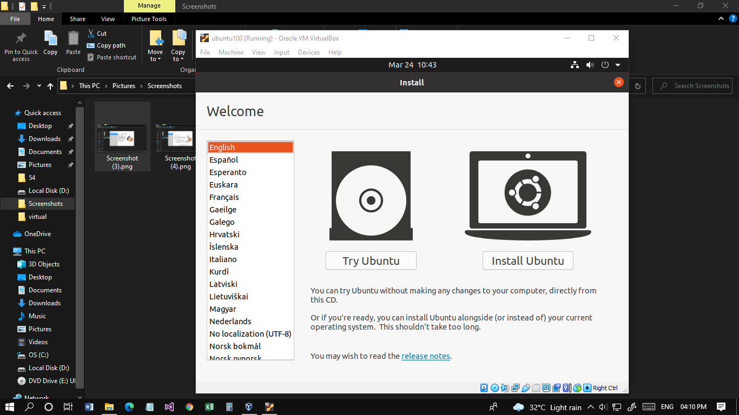

Click 'Continue' button.

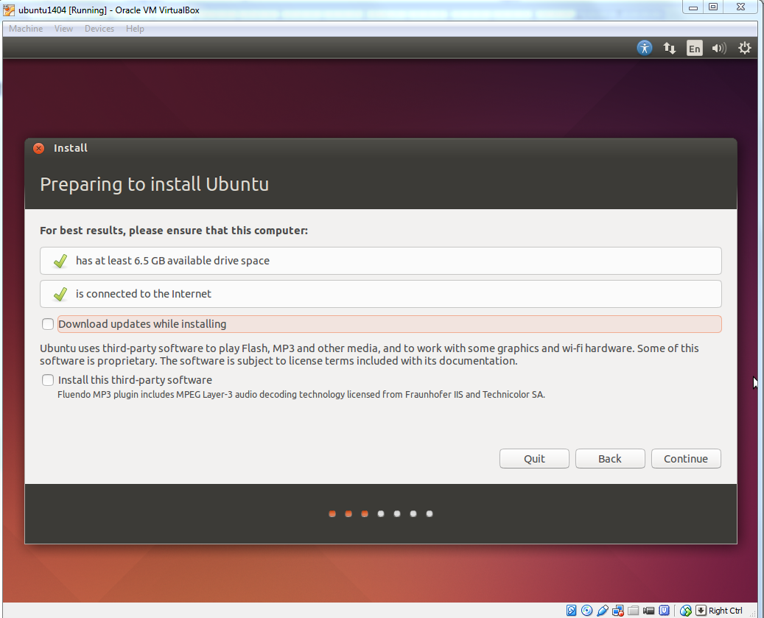

Make sure 'Erase disk and install Ubuntu' option is selected and click 'Install Now' button.

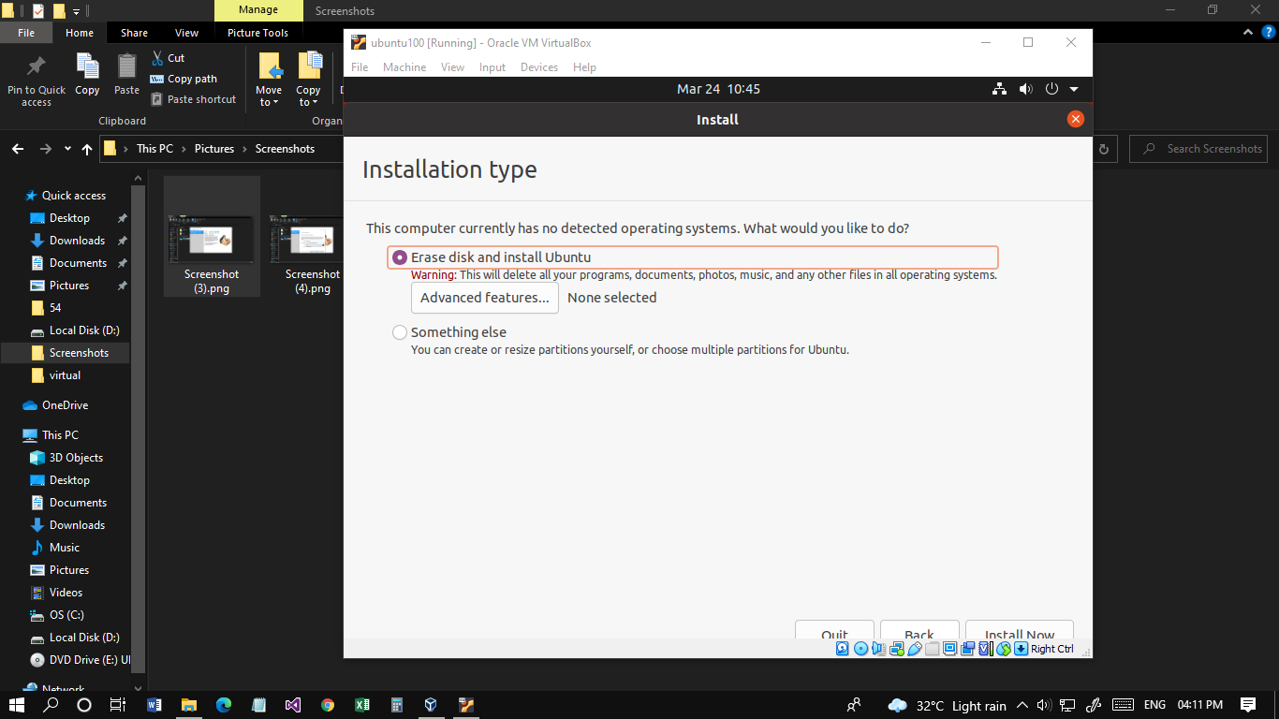

Ubuntu will ask you a few questions. If the default is good, click 'Continue' button.

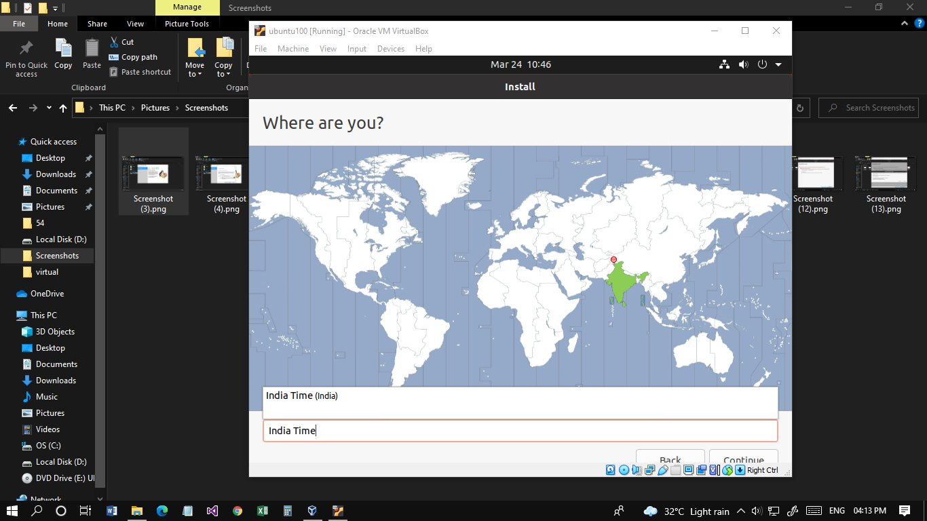

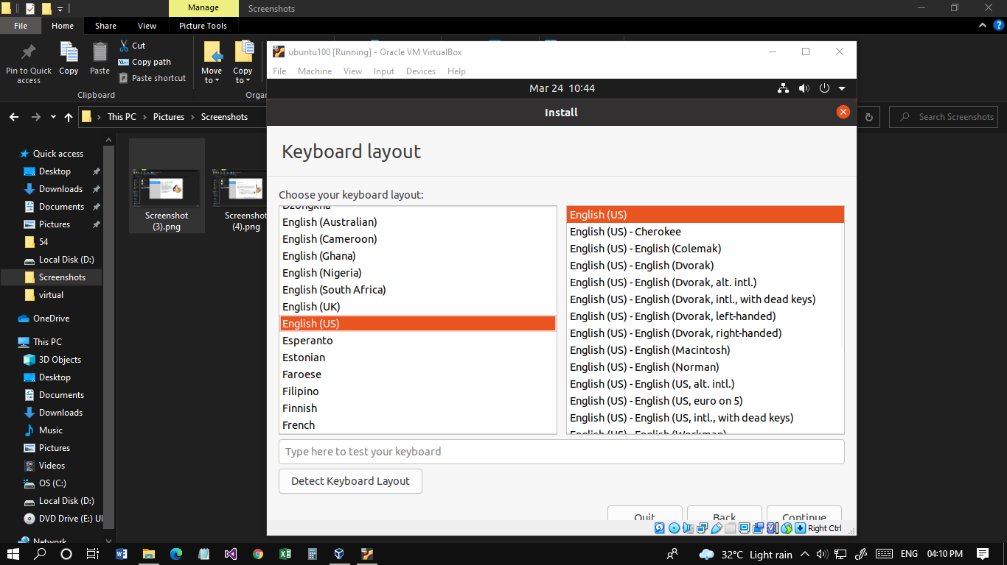

In 'Who are you?' dialog, enter your preferred name, username and password.  Click 'Continue' button.

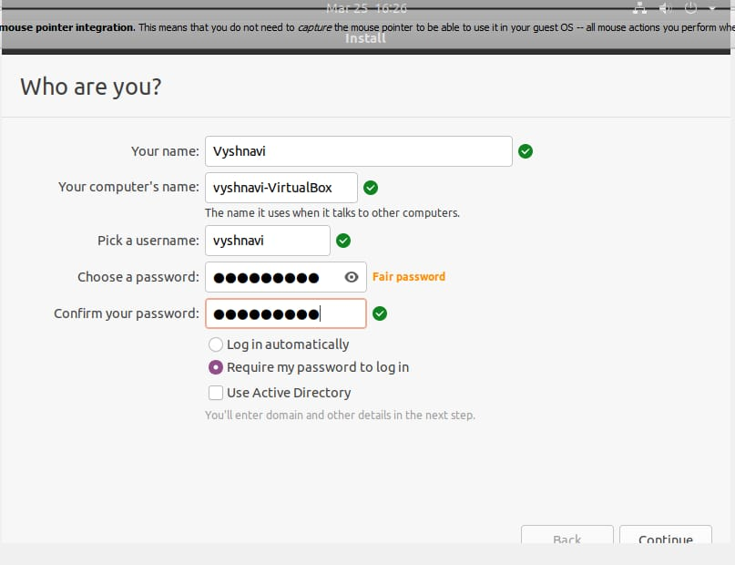

The installation will continue until it is finished.

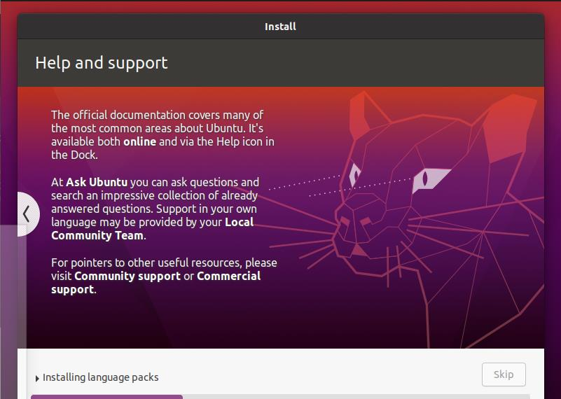

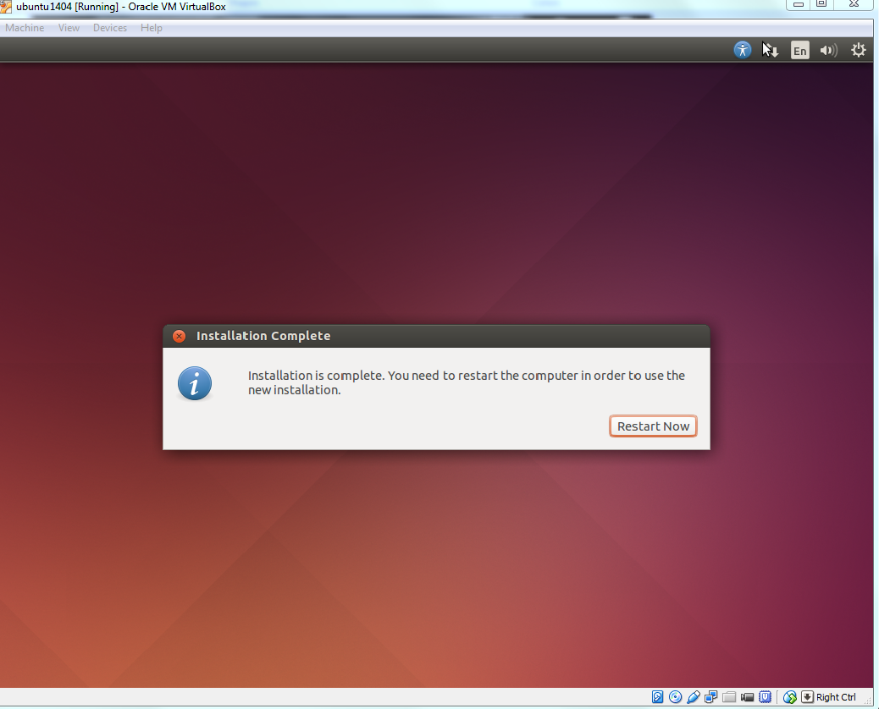

The Ubuntu Desktop OS is ready.

